Eda:
“EDA was performed to identify patterns, relationships, and key factors influencing loan default, which helps in building accurate machine learning models.”
1. DATASET OVERVIEW
The dataset consists of approximately 255,000 records with multiple features including demographic details, financial attributes, and loan-related information.
Key features include:
- Age
- Income
- Loan Amount
- Credit Score
2. TARGET VARIABLE ANALYSIS
The target variable is Default, indicating whether a borrower defaulted on a loan.
The dataset is highly imbalanced, with approximately:
- 88% non-default cases
- 12% default cases
This imbalance suggests that machine learning models may be biased toward predicting non-default outcomes, and appropriate techniques such as class balancing may be required.
3. NUMERICAL FEATURE ANALYSIS
Statistical analysis of numerical features shows that the variables are reasonably distributed.
Key observations:
- Income values are moderately distributed across borrowers
- Credit scores show variation across the population
- Loan amounts are spread across a wide range
4. FEATURE vs TARGET ANALYSIS
The relationship between numerical features and default status reveals important patterns:
- Borrowers with lower credit scores are more likely to default
- Higher debt-to-income (DTI) ratios are associated with increased default risk
- Borrowers with lower income levels show higher probability of default
5. CATEGORICAL FEATURE ANALYSIS
📊 Loan Purpose:
Business loans exhibit the highest default rates, while home loans show the lowest default rates.
📊 Employment Type:
Unemployed individuals have the highest default rates, while full-time employees show the lowest risk.
📊 Education:
Borrowers with lower education levels have higher default rates compared to those with higher education.
These patterns highlight the importance of borrower profile in predicting loan repayment behavior
6. CORRELATION ANALYSIS
Correlation analysis indicates that most features have weak linear relationships with the target variable.
Key observations:
- Credit Score shows a negative correlation with default
- Debt-to-Income ratio shows a positive correlation with default
“Most features show weak linear relationships, indicating that default is influenced by multiple interacting factors rather than a single dominant feature.”
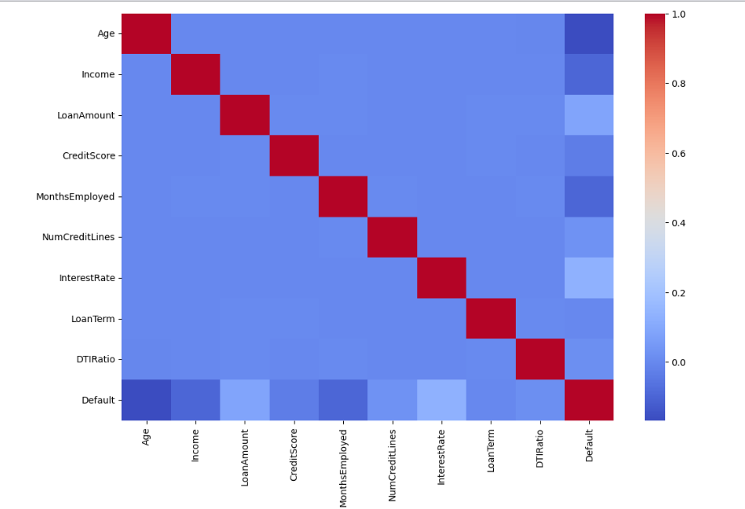
7. FEATURE INTERACTION ANALYSIS
Analysis of feature interactions reveals that:
Borrowers with high loan amounts and low income are more likely to default.
This highlights the importance of the loan-to-income ratio as a key risk indicator.

8. OUTLIER ANALYSIS
Boxplot analysis indicates that the dataset does not contain significant extreme outliers.
The data is well distributed, ensuring stability for machine learning models.

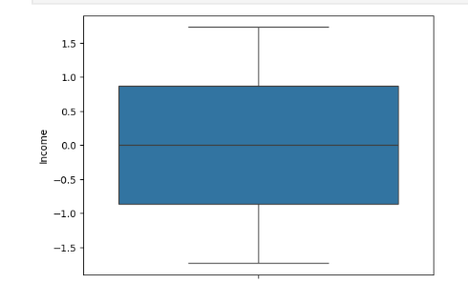

9. SEGMENTATION ANALYSIS
Segmentation analysis provides deeper insights into borrower risk groups:
- Business loans → highest risk
- Unemployed borrowers → highest default rate
- Lower education groups → higher risk
These segments help identify high-risk borrower profiles.

10. Top Factors Affecting Default:
- Credit Score
- Income
- Loan Amount
- Debt-to-Income Ratio
- Employment Type

⚠️ High-Risk Borrower Profile:
Borrowers with low income, low credit score, high DTI ratio, and unstable employment are most likely to default.

